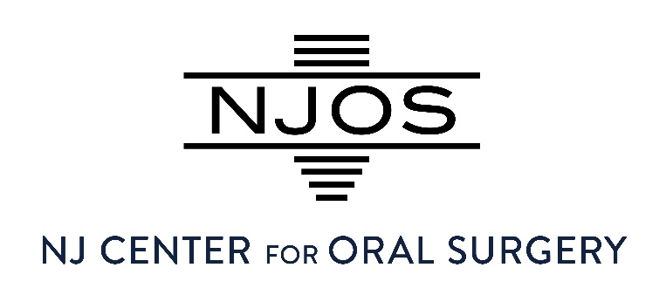
NOTICE OF PRIVACY PRACTICES FOR PROTECTED HEALTH INFORMATION
New Jersey Center For Oral Surgery

THIS NOTICE DESCRIBES HOW MEDICAL INFORMATION ABOUT YOU MAY BE USED AND DISCLOSED AND HOW YOU CAN GET ACCESS TO THIS INFORMATION. PLEASE REVIEW IT CAREFULLY.

1. OUR DUTY TO PROTECT YOUR INFORMATION
We are required by law to maintain the privacy of your Protected Health Information (“PHI”) and to provide you with this Notice of our legal duties and privacy practices. We will follow the terms of this Notice currently in effect.

2. HOW WE MAY USE AND DISCLOSE YOUR INFORMATION
We may use and disclose your PHI for the following purposes:

Treatment: We may use your information to provide, coordinate, or manage your care.
Example: Sharing information with your referring dentist, physician, or another specialist.

Payment: We may use your information to obtain payment for services.
(Example: Submitting claims to your insurance provider or billing services, which may include health and treatment history.)

Healthcare Operations: We may use your information to run our practice and improve care.
(Example: Quality assessment, staff training, licensing, and accreditation activities.)

3. ADDITIONAL USES AND DISCLOSURES
We may also use or disclose your PHI without your written authorization in the following situations:
- As required by law
- Public health reporting
- Health oversight activities
- Judicial or administrative proceedings
- Law enforcement purposes
- To prevent a serious threat to health or safety
- Workers’ compensation claims

4. USES REQUIRING YOUR AUTHORIZATION
We will not use or disclose your PHI for the following without your written authorization:
- Marketing purposes
- Sale of your information
- Uses not described in this Notice
You may revoke your authorization at any time in writing.

5. ELECTRONIC COMMUNICATION (TEXT, EMAIL, PHONE)
We may communicate with you via text message, email, or phone for purposes such as:
- Appointment reminders
- Pre and Post-operative instructions
- Treatment coordination
- Billing and payment notifications
Important:
Standard text messages and email may not be fully secure. We make every effort to safeguard your information by utilizing secure/encrypted emails when Protected Health Information (PHI) is present. By providing your contact information, you acknowledge and accept the potential risks associated with electronic communication.
You may:
- Request alternative communication methods
- Opt out of electronic communications at any time

6. PHOTOGRAPHY, IMAGING, AND RECORDINGS
As part of your care, we may create and use clinical images, including:
- X-rays and CBCT scans
- Intraoral and extraoral photographs
- Surgical documentation images
These images are used for:
- Diagnosis and treatment
- Treatment planning
- Healthcare operations (e.g., education, training, quality improvement)
We will not use identifiable images for marketing, advertising, or public purposes without your separate written authorization.

7. DISCLOSURE TO FAMILY, FRIENDS, AND CAREGIVERS
We may disclose relevant information to a family member, friend, or caregiver who is involved in your care or payment for your care, including:
- Appointment information
- Treatment status
- Billing information
If you are present and able to agree or object, we will give you the opportunity to do so. In order to release any information in writing, please complete a HIPAA Authorization for medical release, located on our website.
If you are unable to agree (e.g., emergency situation), we may disclose information if we determine it is in your best interest.
You may:
- Designate specific individuals we may communicate with
- Restrict or revoke access at any time in writing

8. YOUR RIGHTS REGARDING YOUR INFORMATION
You have the right to:

Access: Request copies of your medical and billing records.

Amend: Request corrections to your records.

Restrict: Request limits on how we use or disclose your information.

Confidential Communications: Request that we contact you in a specific way (e.g., phone, email).

Accounting of Disclosures: Request a list of disclosures we have made.

Paper Copy: Request a paper copy of this Notice at any time.

9. OUR RESPONSIBILITIES
We are required to:
- Maintain the privacy and security of your PHI
- Notify you following a breach of unsecured PHI
- Follow the terms of this Notice
We reserve the right to change this Notice and make the revised version effective for all information we maintain.

10. COMPLAINTS
If you believe your privacy rights have been violated, you may file a complaint with us or with the U.S. Department of Health and Human Services. You will not be penalized for filing a complaint.
Contact for complaints:
Lisa Zack
973-226-8444
lisazack@njcenteros.com

11. CONTACT INFORMATION
If you have questions about this Notice, please contact:
Privacy Officer: Lisa Zack
Phone: 973-226-8444
Email: lisazack@njcenteros.com

